**FOR IMMEDIATE RELEASE**

**MEDIA CONTACTS:**

**Adaora Onyebeke**

[adaora@philharmonicsociety.org](mailto:adaora@philharmonicsociety.org)

(949)-553-2422, ext. 105

**Marie-Songco Torres**

[marie@philharmonicsociety.org](mailto:marie@philharmonicsociety.org)

(949)-553-2422, ext. 230

**VOCTAVE & CANADIAN BRASS RETURN TO ORANGE COUNTY THIS HOLIDAY SEASON WITH FESTIVE FAVORITES AND TIMELESS CLASSICS**

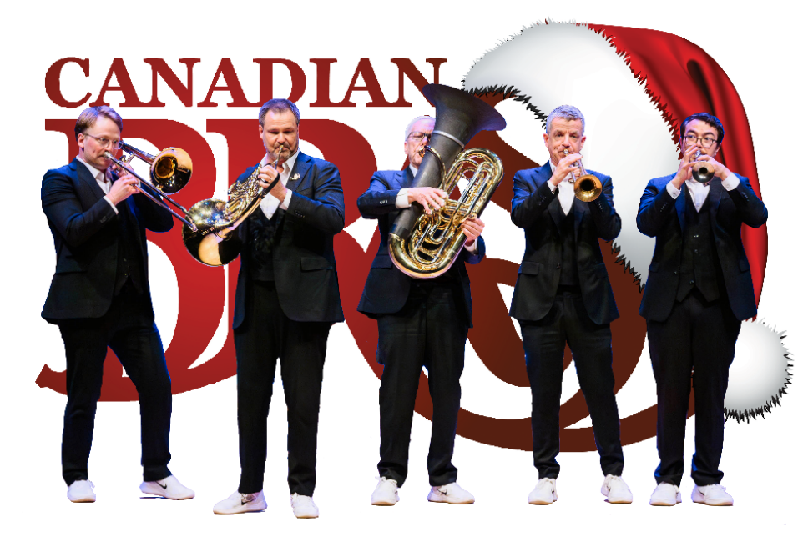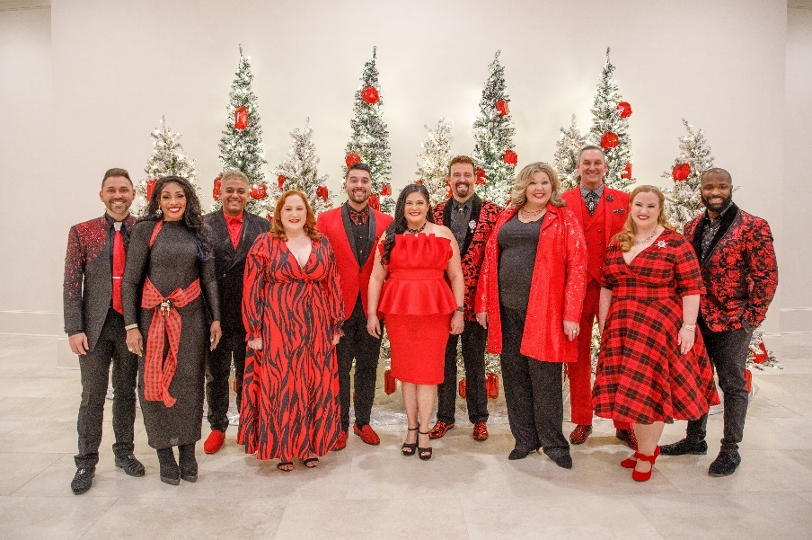

**(IRVINE, CA, November 1, 2024)**

The Philharmonic Society of Orange County rings in the holiday season with two festive concerts, each bringing a unique charm and seasonal spirit. Kicking off the celebrations, the world-renowned **Canadian Brass** returns to Orange County on Thursday, December 12, 2024, at 8pm at the Irvine Barclay Theatre. Known for their “unbeatable blend of virtuosity, spontaneity and humor” (*The Washington Post*), this beloved brass quintet will delight audiences with a program of holiday favorites such as *It’s The Most Wonderful Time of the Year*, *Jingle Bell Rock*, and *A Charlie Brown Christmas*. The holiday cheer continues with **Voctave** on Wednesday, December 18, 2024, at 8pm at the Renée and Henry Segerstrom Concert Hall. The 11-member a cappella group will perform a heartwarming holiday program titled “It Feels Like Christmas,” featuring an array of seasonal tunes.

**CANADIAN BRASS**

Friends Chuck Daellenbach and Gene Watts first came together in 1970 to form a brass quintet—a chamber music setting not entirely new, but never having garnered the success and storied career **Canadian Brass** would achieve over the next 40 years. Masters of concert presentations, Canadian Brass has developed a uniquely engaging stage presence and rapport with audiences. Each of its concerts show the full range from trademark Baroque and Dixieland tunes to new compositions and arrangements created especially for the quintet. The hallmark of any Canadian Brass performance is entertainment, spontaneity, virtuosity and, most of all, fun—but never at the expense of the music. Whatever the style, the music is central and performed with utmost dedication, skill, and excellence.

With a discography of over 130 albums and an extensive world-wide touring schedule, Canadian Brass is an important pioneer in bringing brass music to mass audiences everywhere. It has sold well over two million albums worldwide, with 1.2 million sold in the Nielsen Soundscan era alone (since 1991). It continues to score Billboard chart positions—like with its rousing recording of patriotic songs and marches, *Stars & Stripes: Canadian Brass Salute America*, which spent eight weeks in the Top 25 on the Billboard Classical Chart, peaking at Number Two. Touring legends with an enthusiastic fan base, Canadian Brass plays to packed houses everywhere throughout the U.S., Canada, Japan and Europe. It has also toured Australia, the Middle East, Eastern Europe, and South America, and served as the first brass ensemble from the West to perform in the People’s Republic of China as well as the first brass group to take the main stage at the venerable Carnegie Hall. On numerous occasions Canadian Brass has been invited by the Canadian Government to play for visiting heads of states, becoming one of Canada’s greatest resources and musical ambassadors.

Millions of television viewers have had Canadian Brass in their homes with appearances on *The Tonight Show*, *Today* and *Entertainment Tonight* and recently to more than half a billion viewers for Chinese New Year on China’s most popular station. The group has also appeared as guest artists on *Evening at Pops with John Williams* and the Boston Pops, Beverly Sills’ *Music Around the World*, and numerous PBS specials, including a celebrated appearance on *Sesame Street*.

Irvine Barclay Theatre is located at 4242 Campus Dr, Irvine, CA 92612. Ticket prices for Canadian Brass start at $42 and are available at the Philharmonic Society box office at (949) 553-2422, online at [www.philharmonicsociety.org](http://www.philharmonicsociety.org), at the Irvine Barclay Theatre box office at (949) 854-4646 and online at [www.TheBarclay.org](http://www.TheBarclay.org).

**VOCTAVE**

A capella sensation**, Voctave**, known for their intricate and captivating vocal arrangements, was founded in 2015 by esteemed producer and arranger Jamey Ray. The group brings together a diverse and rich tapestry of musical backgrounds including musical theater, contemporary Christian music, barbershop, pop, and choral music.

Voctave has performed across the globe and has appeared on countless recordings showcasing their versatile talent. Voctave has also collaborated with a host of Grammy, Dove, and American Music Award winners, earning acclaim for their exceptional performances.

Their impressive discography boasts multiple #1 songs and albums on platforms like iTunes, Amazon, and Spotify, and they have made significant strides on *Billboard Magazine’s* charts, ranking in the top 25. With over 200 million views across social media platforms, Voctave’s impact on the a cappella scene is undeniable. Their albums are widely available on all digital music and streaming platforms, allowing fans worldwide to experience their stunning vocal artistry.

Segerstrom Center for the Arts, Renée and Henry Segerstrom Concert Hall, is located at 615 Town Center Drive, Costa Mesa, CA 92626. Ticket prices for Voctave start at $26 and are available at the Philharmonic Society box office at (949) 553-2422, online at www.philharmonicsociety.org, at the Center box office at (714) 556-2787, and online at www.scfta.org.

**ABOUT THE PHILHARMONIC SOCIETY:**

Founded in 1954 as Orange County’s first music organization, the Philharmonic Society of Orange County presents national and international performances of the highest quality and provides dynamic and innovative music education programs for individuals of all ages to enhance the lives of Orange County audiences through music.

Since its inception, the Philharmonic Society has evolved and grown with the county’s changing landscape, presenting artists and orchestras who set the standard for artistic achievement from Itzhak Perlman, Gustavo Dudamel, Yo-Yo Ma, and Renée Fleming to the Berlin Philharmonic, Vienna Philharmonic, Chicago Symphony Orchestra, and many others. In addition, the Philharmonic Society celebrates multi-disciplinary performances under its Eclectic Orange brand and embraces music from a wide range of countries with its World Music performances. Its celebrated concerts introduce children to classical music with creative and inspiring performances, instilling music appreciation for future generations.

The Philharmonic Society’s nationally recognized Youth Music Education Programs, offered free of charge, engage more than 100,000 students annually through curriculum-based music education programs that aim to inspire, expand imaginations, and encourage learning at all levels. These programs are made possible by the Committees of the Philharmonic Society comprised of 500 volunteer members who provide more than 90,000 hours of in-kind service each year. As a key youth program, the exceptional Orange County Youth Symphony and String Ensemble provide top-tier training to the area’s most talented young musicians through multi-level ensemble instruction, leadership training, touring opportunities, challenging professional repertoire, and performances in world-class venues. The Philharmonic Society also promotes life-long learning by connecting with colleges and universities to conduct masterclasses and workshops and providing pre-concert lectures to introduce audiences to program selections.

**MEDIA CONTACTS :**

**MEDIA CONTACTS:**

**Adaora Onyebeke**

[adaora@philharmonicsociety.org](mailto:adaora@philharmonicsociety.org)

(949)-553-2422, ext. 105

**Marie-Songco Torres**

[marie@philharmonicsociety.org](mailto:marie@philharmonicsociety.org)

(949)-553-2422, ext. 230

**WHAT: The Holidays with Canadian Brass**

**Chuck Daellenbach**, tuba

**Jeff Nelsen**, horn

**Keith Dyrda**, trombone

**Mikio Sasaki**, trumpet

**Joe Burgstaller**, trumpet

**WHEN:** Thursday, December 12, 2024, at 8pm

**PROGRAM:**  To be announced from the stage.

Selections may include*:*

*It’s The Most Wonderful Time of the Year*

*Jingle Bell Rock*

*A Charlie Brown Christmas*

**WHERE:** Irvine Barclay Theatre

4242 Campus Dr, Irvine, CA 92612

**TICKETS** Ticket prices start at $42 and are available at the Philharmonic Society box office at (949) 553-2422, and online at philharmonicsociet.org

**AND**

Tickets are also available at the Irvine Barclay

**INFORMATION:** Theatre box office at (949) 854-4646, and online at www.TheBarclay.org

**MEDIA CONTACTS :**

**MEDIA CONTACTS:**

**Adaora Onyebeke**

[adaora@philharmonicsociety.org](mailto:adaora@philharmonicsociety.org)

(949)-553-2422, ext. 105

**Marie-Songco Torres**

[marie@philharmonicsociety.org](mailto:marie@philharmonicsociety.org)

(949)-553-2422, ext. 230

**WHAT: Voctave**“It Feels Like Christmas”

**E.J. Cardona**

**Tiffany Coburn**

**Ashley Espinoza**

**Karl Hudson**

**Chrystal Johnson**

**Kate Lott**

**Drew Ochoa**

**Jamey Ray**

**Aaron Stratton**

**Kurt Von Schmittou**

**Sarah Whittemore**

**WHEN:** Wednesday, December 18, 2024, at 8pm

**PROGRAM:**  To be announced from the stage.

**WHERE:** Renée & Henry Segerstrom Concert Hall

615 Town Center Drive

Costa Mesa, CA 92626

**TICKETS** Ticket prices start at $26 and are available at the Philharmonic Society box office at (949) 553-2422, and online at www.philharmonicsociety.org.

**AND**

Tickets are also available at the Center’s box office at (714) 556-2787,

**INFORMATION:** and online at www.scfta.org.